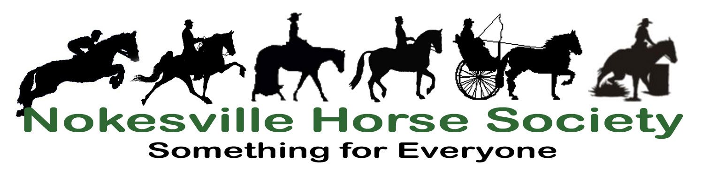
PO Box 132
Nokesville, VA 20182
www.NokesvilleHorseSociety.org

April 7, 2008

To: The Prince William County Board of County Supervisors

The Nokesville Horse Society Board of Directors in collaboration with the Northern Virginia Coalition of Equestrian Organizations, Inc. (NVCEO) supports the transfer of the Silver Lake Property to the Prince William County Park Authority.

The PWCPA has repeatedly demonstrated a willingness and ability to work toward the public good in developing and maintaining exceptional recreation facilities, park land, and trails. They have been extremely responsive to citizen input and have an outstanding reputation for good stewardship of public lands.

The PWCPA proposal regarding the use of the Silver Lake Property is clearly in the best interest of all Prince William Country residents.

Thank you for your consideration.

//Roberta L. McIntyre//
President
Nokesville Horse Society

